**Nexus Sonatype**

Nexus Architecture:

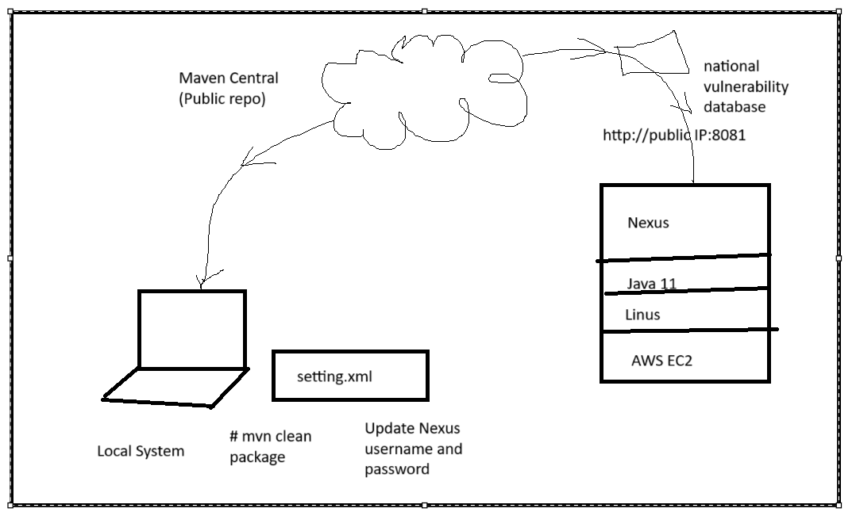

Sonatype Nexus is a tool used to store and manage software components, like libraries, code, and other files that developers use to build software. It as a digital warehouse where developers can store their code and other reusable software pieces, like Java libraries or Docker images, and then easily retrieve them whenever needed.

* **Artifact storage**: It keeps things like software libraries, code, and tools in one place.
* **Repositories**: It organizes this stored software into different categories (called repositories), like one for your own code or one for third-party code.

Blob Storage:

Local: System Storage

Cloud: Integrate Nexus with S3

Create a S3 Blob Storage to store images in S3 Bucket.

1. Create S3 Bucket
2. Create IAM user
3. Provide details to S3 Blob Storage.

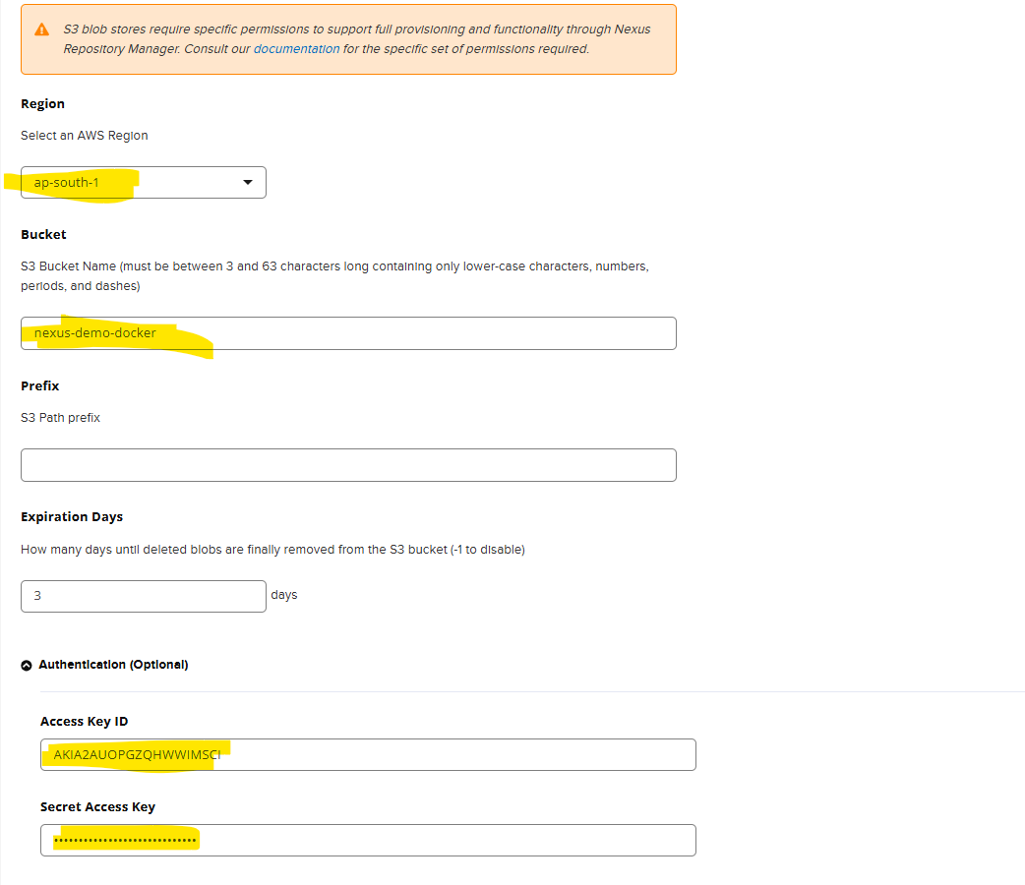

1. Click on Save.

Create Repository in nexus

1. Click on create Repository.
2. Select Docker Hosted Repo.
3. Give the name of Repo. netflix-ms
4. Select below options.

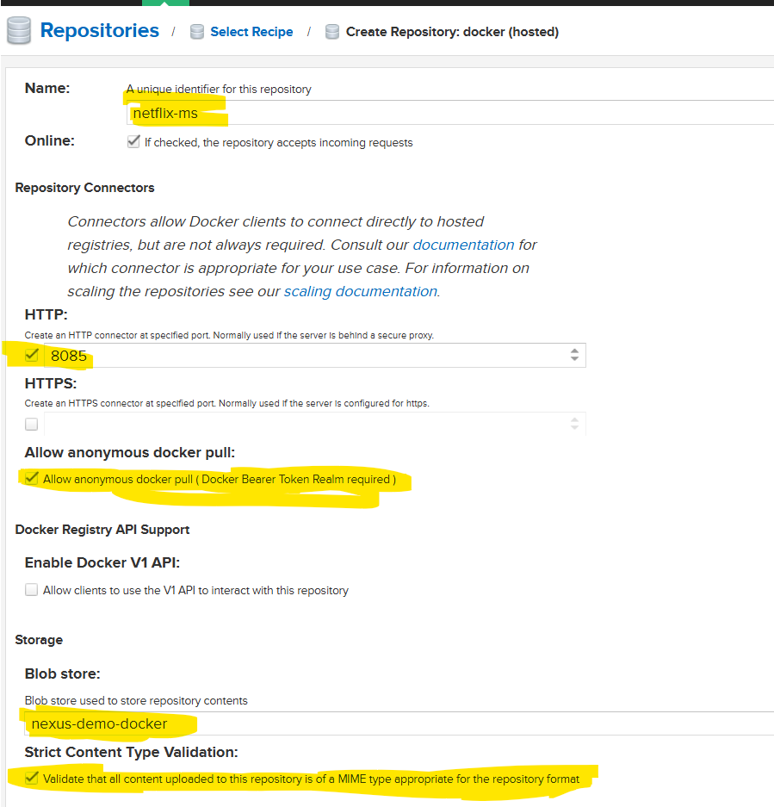

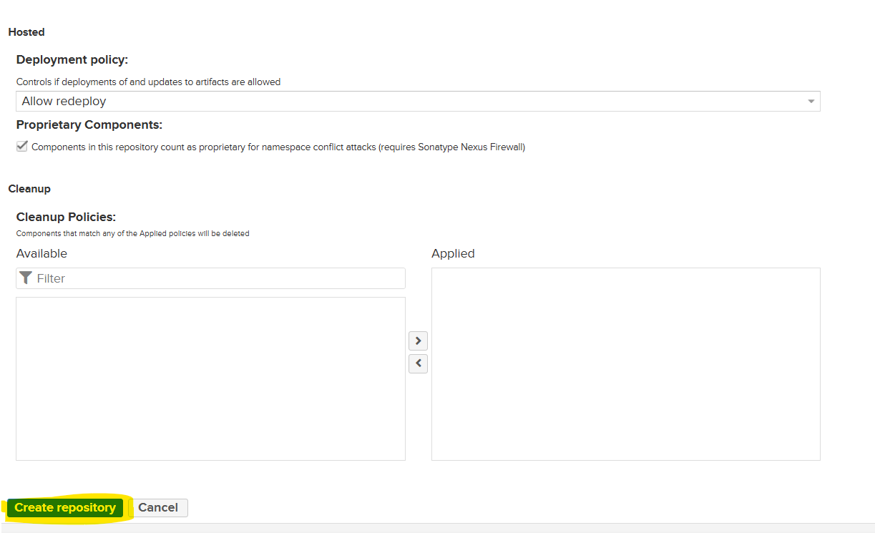

1. Click on create Repository.
2. Once the repo is created, you will get one URL. You have to use this URL in your Jenkins Pipeline.

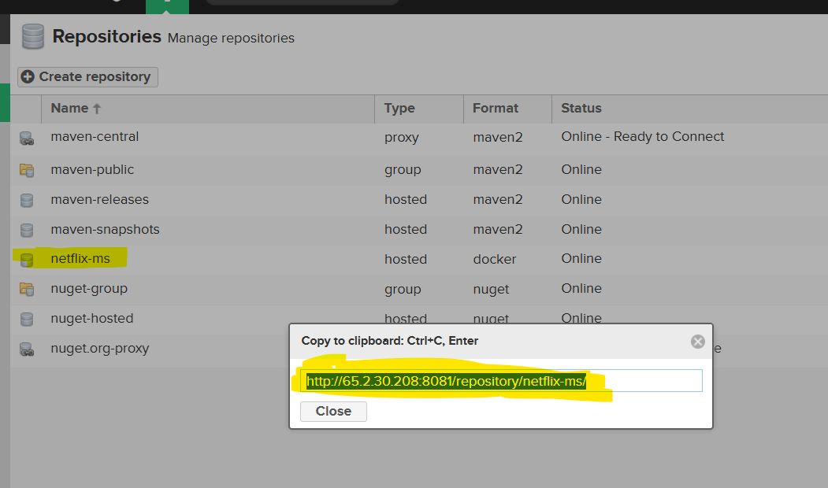

Before Pushing the image, do below task.

Go to realms.

Move docker related realms to active.

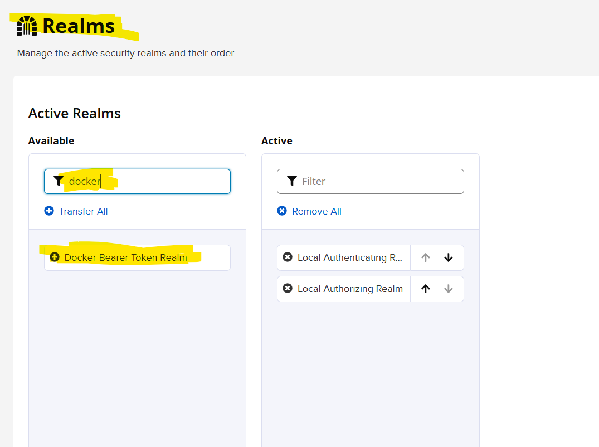

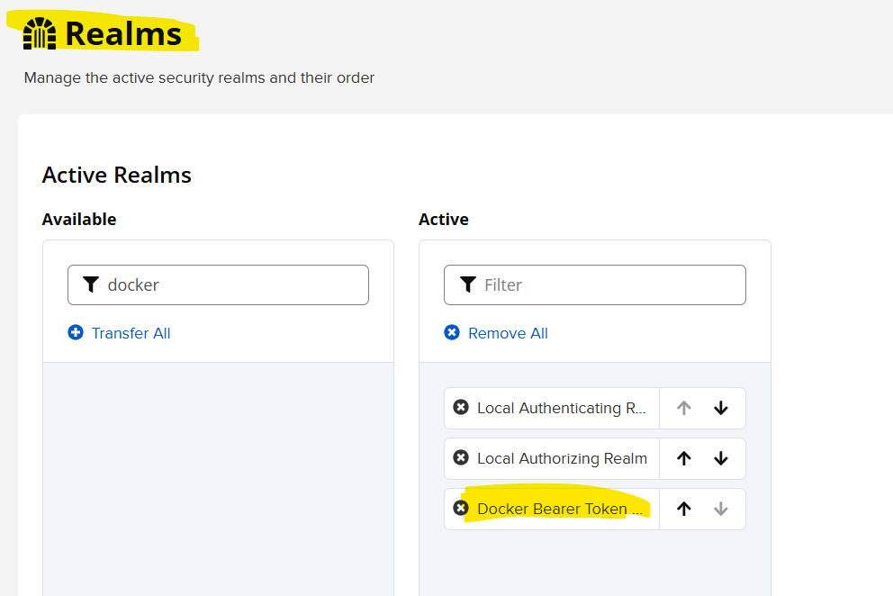

Click on Save.

Go to Jenkins Master terminal

#Add the file daemon.json and enter the nexus ip.

cat > /etc/docker/daemon.json

{ "insecure-registries" : [ "65.2.150.176:8085" ] } #Add Nexus Public IP

Restart the docker service

Service docker restart

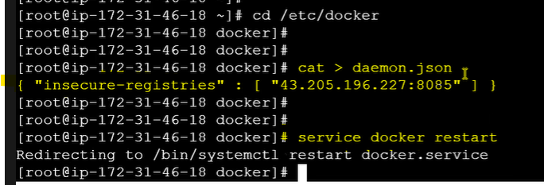

Use chmod command if the docker service is not started.

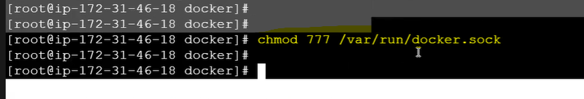

**Credentials 'nexus-credentials' is of type 'Secret text' where 'com.cloudbees.plugins.credentials.common.StandardUsernamePasswordCredentials' was expected**

Need to create nexus Username and Password credentials.

Give nexus username in credentials.

Give nexus password in credentials.